

**Adama Science and Technology University**

**School of Electrical Engineering and Computing**

**Course Title:**Electronic Circuit I

**Course Number:**ECE2101

**Lab:** Experiment Number 3

**Title:**Zener Diode Voltage Regulator

**Prepared by:**

**Name ID No.**

**Submitted to: Lecturer Zewdu**

Date of conduction: December 8, 2016

Date of submission: December 15, 2016

**Acknowledgement**

We would like to acknowledge our lab assistantfor his support and explanation in the laboratory. Through the group work and experiment we were able to comprehend the topics that were raised and able to communicate with each other well.

**Theoretical Background**

The Zener diode is like a general-purpose signal diode. When biased in the forward direction it behaves just like a normal signal diode, but when a reverse voltage is applied to it, the voltage remains constant for a wide range of currents.

 Avalanche Breakdown: There is a limit for the reverse voltage. Reverse voltage can increase until the diode breakdown voltage reaches. This point is called Avalanche Breakdown region. At this stage maximum current will flow through the Zener diode. This breakdown point is referred as “Zener voltage”.

The Zener Diode is used in its "reverse bias". From the I-V Characteristics curve we can study that the Zener diode has a region in its reverse bias characteristics of almost a constant negative voltage regardless of the value of the current flowing through the diode and remains nearly constant even with large changes in current as long as the Zener diodes current remains between the breakdown current IZ(min) and the maximum current rating IZ(max).

This ability to control itself can be used to great effect to regulate or stabilize a voltage source against supply or load variations. The fact that the voltage across the diode in the breakdown region is almost constant turns out to be an important application of the Zener diode as a voltage regulator.

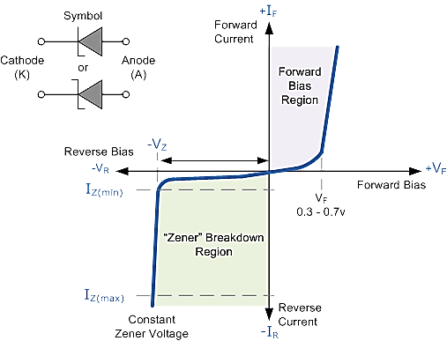

***Figure 1: Zener Diode Characteristics curve***

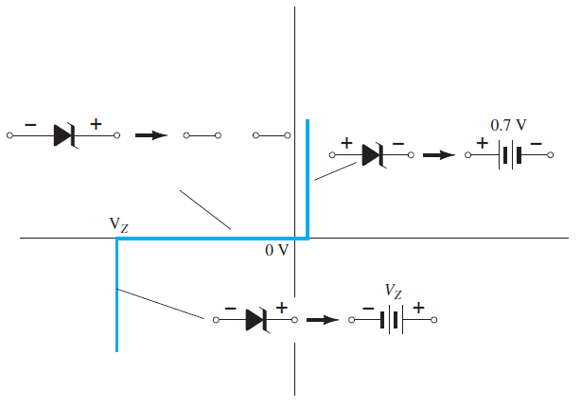

***Figure 2: Approximate equivalent circuits for the Zener diode in the three possible regions of application***

The forward bias region of a Zener diode is identical to that of a regular diode. The typical forward voltage at room temperature with a current of around 1 mA is around 0.6 volts. In the reverse bias condition the Zener diode is an open circuit and only a small leakage current is flowing as shown on the exaggerated plot. As the breakdown voltage is approached the current will begin to avalanche. The initial transition from leakage to breakdown is soft but then the current rapidly increases as shown on the plot. The voltage across the Zener diode in the breakdown region is very nearly constant with only a small increase in voltage with increasing current. At some high current level the power dissipation of the diode becomes excessive and the part is destroyed. There is a minimum Zener current, Iz(min), that places the operating point in the desired breakdown. There is a maximum Zener current, Iz(max), at which the power dissipation drives the junction temperature to the maximum allowed. Beyond that current the diode can be damaged.

The function of a regulator is to provide a constant output voltage to a load connected in parallel with it in spite of the ripples in the supply voltage or the variation in the load current and the Zener diode will continue to regulate the voltage until the diodes current falls below the minimum IZ(min) value in the reverse breakdown region. It permits current to flow in the forward direction as normal, but will also allow it to flow in the reverse direction when the voltage is above a certain value - the breakdown voltage known as the Zener voltage. The Zener diode specially made to have a reverse voltage breakdown at a specific voltage. Its characteristics are otherwise very similar to common diodes. In breakdown the voltage across the Zener diode is close to constant over a wide range of currents thus making it useful as a shunt voltage regulator.

The purpose of a voltage regulator is to maintain a constant voltage across a load regardless of variations in the applied input voltage and variations in the load current. A typical Zener diode shunt regulator is shown in Figure 3. The resistor is selected so that when the input voltage is at VIN(min) and the load current is at IL(max) that the current through the Zener diode is at least Iz(min). Then for all other combinations of input voltage and load current the Zener diode conducts the excess current thus maintaining a constant voltage across the load. The Zener conducts the least current when the load current is the highest and it conducts the most current when the load current is the lowest.

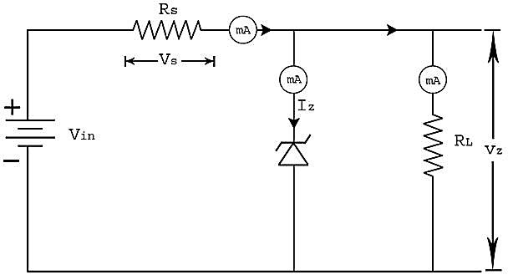

***Figure3: Basic Zener Regulator***

If there is no load resistance, shunt regulators can be used to dissipate total power through the series resistance and the Zener diode. Shunt regulators have an inherent current limiting advantage under load fault conditions because the series resistor limits excess current.

 A Zener diode of break down voltage Vz is reverse connected to an input voltage source Vi across a load resistance RL and a series resistor RS. The voltage across the Zener will remain steady at its break down voltage VZ for all the values of Zener current IZ as long as the current remains in the break down region. Hence a regulated DC output voltage V0 = VZ is obtained across RL, whenever the input voltage remains within a minimum and maximum voltage.

**Lab – 3: Zener Diode Voltage Regulation**

**Objectives:**

* To Study the application of Zener diodes as simple voltage regulator.

**Apparatus Used:**

* DC power supply

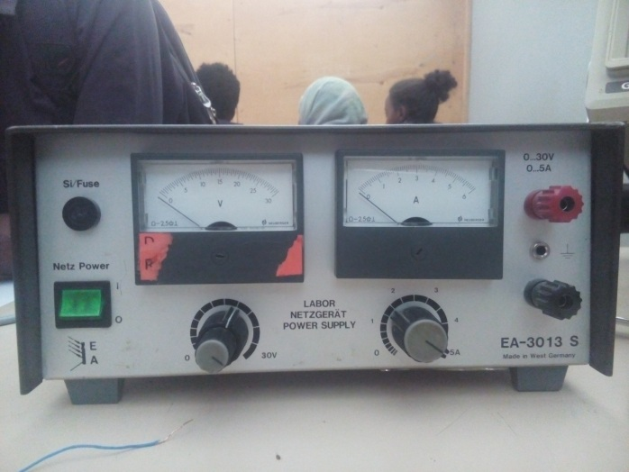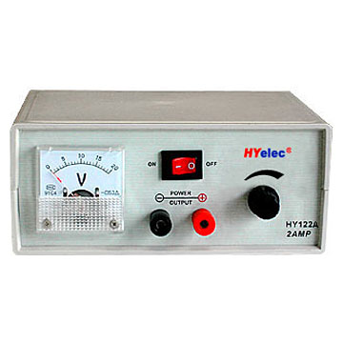

* Digital Multimeter (DMM)

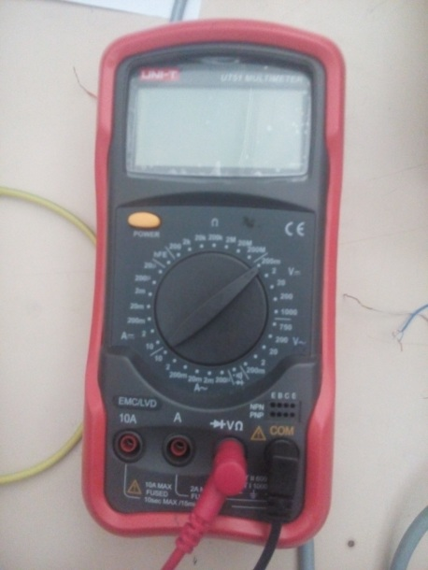****

* Zener Diode (6 – 10V)

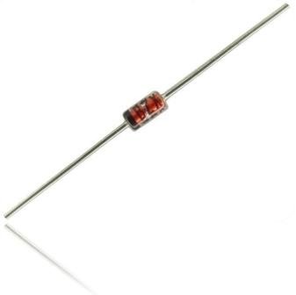

* Resistors: 1.2 k $Ω$, 1.2 k $Ω$

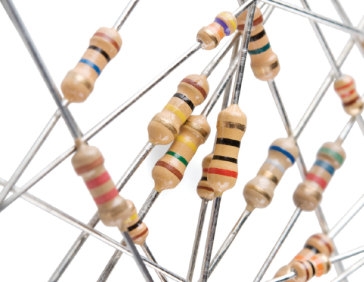

* Breadboard

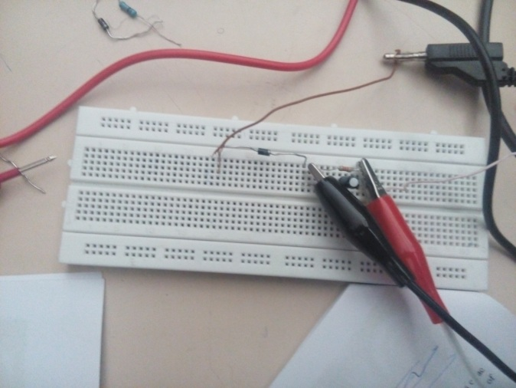

**Procedures**

**Zener Diode Voltage Regulation**

1. We placed our instruments on a good surface to begin our experiment.



***Figure 4: Students getting prepared for their experiment***

1. Then we set our DC power supply to 15V.
2. Thereafter we constructed the following circuit on a bread board. The Load resistance RL and the Zener diode are connected in parallel. Then we connected an arbitrary resistor in series with the power source. The combination of the Zener and the load resistor is connected on series with the arbitrary resistance.

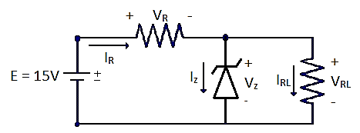

***Figure 5: Zener Diode circuit as a voltage regulator***

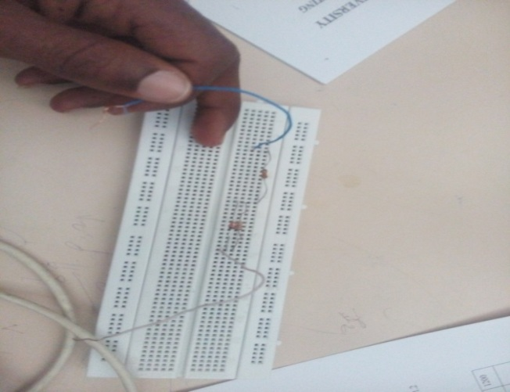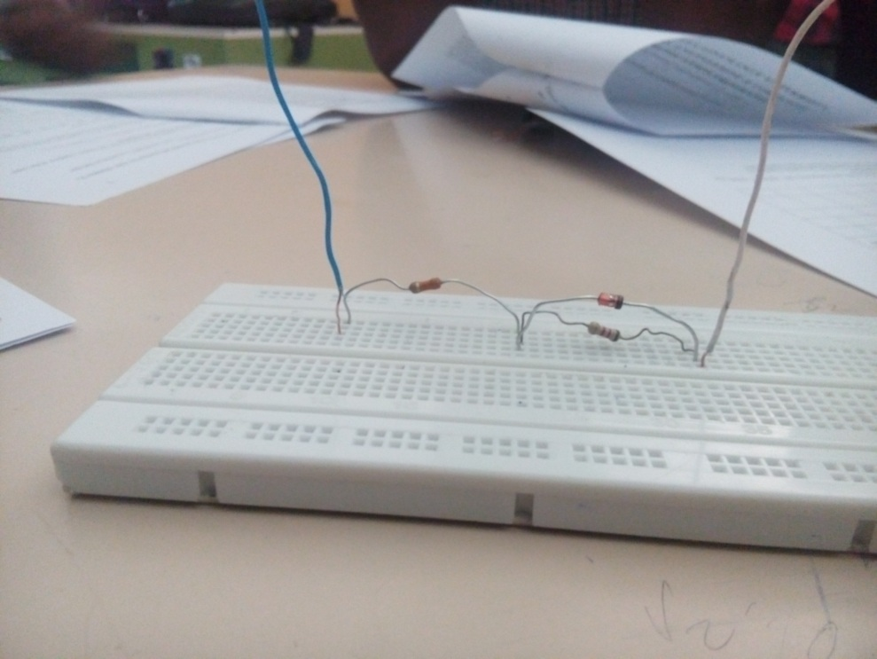

***Figure 6: Practical circuit consisting of a Zener Diode as a voltage regulator***

1. Then by using a fixed load resistor at 1.2 k $Ω$ and an arbitrary resistor at 1.2 k $Ω$, we measured the turn-on voltage of the Zener diode by varying the input DC voltage.



***Figure 7: Students measuring voltage by using Digital Multimeter***

1. After completing the above, we moved to a fixed power source and varying load resistor. The arbitrary resistor was kept at 1.2 k $Ω$, but the 1.2 k $Ω$ load resistor was replaced by a rheostat which we varied to get the resistance that turned on the Zener diode. The power source was kept at 15V during the second phase of our experiment.



***Figure 8: Students using a rheostat***

1. Finally we measured the load resistance that would turn on the Zener diode at constant voltage by varying the rheostat.

**Result and Discussion**

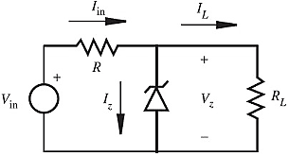

***Figure 9: Zener Diode as A voltage regulator***

**Measuring Zener Diode Turn on Voltage**

|  |  |  |  |  |  |  |  |  |  |  |  |
| --- | --- | --- | --- | --- | --- | --- | --- | --- | --- | --- | --- |
| Table 1 | | | | | | | | | | | |
| **E(V)** | 0 | 2 | 4 | 6 | 8 | 10 | 12 | 14 | 16 | 18 | 20 |
| **VZ (V)** | 0 | 0.98 | 1.98 | 2.99 | 4.01 | 5 | 6 | 7.01 | 7.44 | 7.45 | 7.46 |
| **VR (V)** | 0 | 0.98 | 1.98 | 2.99 | 4 | 4.98 | 5.99 | 7 | 8.54 | 10.54 | 12.57 |
| **IZ (mA)** | 0 | 0 | 0 | 0 | 0 | 0 | 0 | 0 | 0.8 | 2.6 | 4.3 |
| **IRL (mA)** | 0 | 0.7 | 1.6 | 2.5 | 3.3 | 4.1 | 4.9 | 5.7 | 6.2 | 6.2 | 6.2 |
| **IR (mA)** | 0 | 0.7 | 1.6 | 2.5 | 3.3 | 4.1 | 5.0 | 5.8 | 7.1 | 8.8 | 10.5 |

* The Vz versus Iz graph will look as follows:

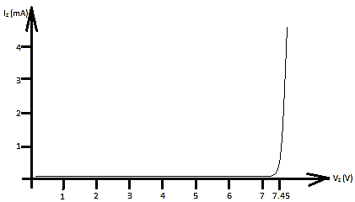

***Figure 10: Zener Diode (reverse bias mode) Current versus Voltage graph for a voltage regulating circuit (varying DC source)***

* The regulated voltage that is delivered to the load is 7.45V.
* From table 1 we can see that IR = Iz + IRL and E = VZ + VR. (Any error that is seen is due to errors that occur during experiment).
* To calculate the Zener resistance we should know the maximum current rating of the diode which is not given. Since we can’t determine the Zener resistance.
* Rather we have used the following measurmnts.

Izmin = 0.8 and Izmax = 4.3 Iz = 4.3 – 0.8 = 3.3 mA

**Rz** = $\frac{Vz}{Iz}$ = $\frac{7.45}{3.3}$ = 2.5 k $Ω$.

|  |  |  |  |  |  |  |  |  |  |  |  |  |
| --- | --- | --- | --- | --- | --- | --- | --- | --- | --- | --- | --- | --- |
| Table 2 | | | | | | | | | | | | |
| **RL()** | 400 | 480 | 560 | 720 | 800 | 880 | 960 | 1040 | 1120 | 1200 | 1260 | 1300 |
| **VZ (V)** | 3.7 | 4.32 | 4.69 | 5.58 | 6.00 | 6.29 | 6.56 | 6.88 | 7.2 | 7.44 | 7.45 | 7.44 |
| **VR (V)** | 11.24 | 10.66 | 10.26 | 9.43 | 8.91 | 8.61 | 8.32 | 8.12 | 7.78 | 7.51 | 7.52 | 7.45 |
| **IZ (mA)** | 0 | 0 | 0 | 0 | 0 | 0 | 0 | 0 | 0 | 0 | 0.3 | 0.5 |
| **IRL (mA)** | 9.4 | 8.9 | 8.5 | 7.8 | 7.4 | 7.2 | 6.7 | 6.7 | 6.4 | 6.4 | 6.0 | 5.7 |
| **IR (mA)** | 9.3 | 8.8 | 8.6 | 7.8 | 7.4 | 7.2 | 6.7 | 6.7 | 6.5 | 6.5 | 6.2 | 6.2 |

* The Zener Diode Current versus Voltage graph will look as follows:

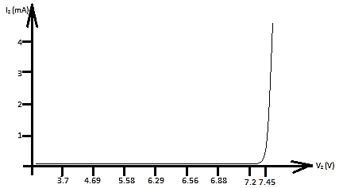

***Figure 11: Zener Diode (reverse bias mode) Current versus Voltage graph for a voltage regulating circuit (Varying load resistor)***

* The minimum load resistance need to turn on the Zener diode is 1200 ~ 1260 $Ω$. Due to experimental difficulties we were unable to pinpoint the exact resistance because the rheostat is very difficult to adjust.

RLmin = 1200 ~ 1260 $Ω$

**Observations and Conclusion**

We have observed the following points:

* Until the voltage across the load resistor reaches the Zener diode voltage, the Zener diode remains turned off.
* When the Zener diode is turned on, the voltage across the Zener diode and the load resistor remains constant even though we have a changing current.
* From table 1 and table 2 we can see that the sum of the currents through the Zener diode and the Load resistor is equal to the current through the arbitrary resistor.
* From table 1 and table 2 we can see that the sum of the voltage across the Zener diode (the load resistance) and the arbitrary resistance is equal to the source voltage.

**References**

* Electronic devices and circuit Theory 11th edition, R. L. Boylestad and L. Nashelsky
* Electronic Principles 7th edition, Albert Malvino and David J. Bates



**Thank you!!!**